**DATABASE PROJECT**

**Introduction:**

**Scenario:**

ER DIAGRAM

**NORMALISATION**

**Has** (Car Expo Ltd has Bank accounts)

UNF: (CompID, CompName, CompPhone, Address, AccID, AccBalance, AccTransactions)

• CompPhone is a multivalued attribute

1NF:

1. CompID, CompName, Street, City, AccID, AccName, AccBalance, AccTransactions

2NF:

1. CompID, CompName, Street, City
2. CompID, CompPhone
3. AccID, AccName, AccBalance, AccTransations, CompID

3NF:

1. CompID, CompName
2. CompID, Street, City
3. CompID, CompPhone
4. AccID, AccName, AccBalance, AccTransation, CompID

**Sells** (Salesman sells car)

UNF: (SM_ID, SMName, CarID, CarCondition, CarType, CarReg)

1NF:

1. SM_ID, SMName, CarID, CarCondition, CarType, CarReg

2NF:

1. SM_ID, SMName
2. CarID, CarCondition, CarType, CarReg
3. SM_ID, SMName

3NF:

1. SM_ID, SMName
2. CarID, CarCondition, CarType
3. CarID, CarReg
4. SM_ID, SMName

**Owns** (Car Expo Ltd owns car garages)

UNF: (CompID, CompName, CompPhone, Address, SlotID, GPhone)

• CompPhone is a multivalued attribute

1NF:

1. CompID, CompName, Street, City, SlotID, GPhone

2NF:

1. CompID, CompName, Street, City
2. CompID, Phone
3. SlotID, Gphone, CompID

3NF:

1. CompID, CompName
2. CompID, Street, City
3. CompID, CompPhone
4. SlotID, Gphone, CompID

**Keeps** (Car garage keeps cars)

UNF (Car_ID, CarCondition, CarReg, SlotID, Gphone)

1NF:

1. Car_ID, CarCondition, CarReg, SlotID, Gphone)

2NF:

1. CarID, CarCondition, SlotID
2. CarID, Car_Reg
3. SlotID, Gphone

3NF:

1. CarID, CarCondition, SlotID
2. CarID, Car_Reg
3. SlotID, Gphone

**Work for** (Employees work for Car Expo Ltd)

UNF: (EmpID, EmpName, CompID, CompName, CompPhone, Address)

• CompPhone is a multivalued attribute

1NF:

1. EmpID, FN, LN, CompID, CompName, Street, City

2NF:

1. EmpID, FN, LN, CompID
2. CompID, CompPhone
3. CompID, CompName, Street, City

3NF:

1. EmpID, FN, LN, CompID
2. CompID, CompPhone
3. CompID, CompName
4. CompID, Street, City

**Imports and Exports** (Dealer imports and exports cars)

UNF (D_ID, DName, Car_ID, CarCondition, CarType, CarReg)

1NF:

1. D_ID, DName, Car_ID, CarCondition, CarType, CarReg

2NF:

1. D_ID, DName
2. Car_ID, CarCondition, CarType, CarReg
3. D_ID, Car_ID

3NF:

1. D_ID, DName
2. CarID, CarCondition, CarType
3. CarID, CarReg
4. D_ID, Car_ID

**Manages** (Managers manage cars)

UNF: (MgrID, MgrName, MgrPhone, CarID, CarCondition, CarType, CarReg)

* CompPhone is a multivalued attribute

1NF:

1. MgrID, MgrName, CarID, CarCondition, CarType, CarReg

2NF:

1. MgrID, MgrName
2. MgrID, MgrPhone
3. Car_ID, CarCondition, CarType, CarReg
4. MgrID, CarID

3NF:

1. MgrID, MgrName
2. MgrID, MgrPhone
3. CarID, CarCondition, CarType,
4. CarID, CarReg
5. MgrID, CarID

**Sold to** (Cars sold to customers)

UNF: (CarID, CarCondition, CarType, CarReg, C_ID, CEmail, CName)

1NF:

1. CarID, CarCondition, CarType, CarReg, C_ID, CEmail, CName

2NF:

1. CarID, CarCondition, CarType, CarReg
2. C_ID, CEmail, CName

3NF:

1. CarID, CarType, Car Condition
2. CarID, CarReg
3. C_ID, CEmail, CName
4. CarID, C_ID

**Guards** (Security guards car garage)

UNF: (SecID, SecName, SlotID, GPhone)

1NF:

1. SecID, SecName
2. SlotID, GPhone
3. SecID, SlotID

3NF:

1. SecID, SecName
2. SlotID, GPhone
3. SecID, SlotID

**Maintains** (Cleaners maintains car)

UNF(CL_ID, CL_Nam,e, CarID, CarType, Car Condition, CarReg)

1NF:

1. CL_ID, CLName, CarID, Car Condition, CarType, Car Reg

2NF:

1. CL_ID, CLName, CarID
2. CarID, Car Condition, CarType
3. CarID, CarReg

3NF: Same as 2NF

**Maintains** (Mechanic maintains car)

UNF(CL_ID, CL_Nam,e, CarID, CarType, Car Condition, CarReg)

1NF:

1. MecID, MecName, CarID, Car Condition, CarType, Car Reg

2NF:

1. MecID, MecName, CarID
2. CarID, Car Condition, CarType
3. CarID, CarReg

3NF: Same as 2NF

**Total table:**

1. CompID, CompName, CompPhone
2. CompID, Street, City
3. ~~CompID, CompPhone~~
4. AccID, AccName, AccBalance, AccTransation, CompID
5. SM_ID, SMName
6. CarID, CarCondition, CarType
7. CarID, CarReg
8. ~~SM_ID, SMName~~
9. ~~CompID, CompName~~
10. ~~CompID, Street, City~~
11. ~~CompID, CompPhone~~
12. SlotID, Gphone, CompID
13. CarID, CarCondition, SlotID
14. ~~CarID, Car_Reg~~
15. ~~SlotID, Gphone~~
16. EmpID, FN, LN, CompID
17. ~~CompID, CompPhone~~
18. ~~CompID, CompName~~
19. ~~CompID, Street, City~~
20. D_ID, DName
21. ~~CarID, CarCondition, CarType~~
22. ~~CarID, CarReg~~
23. D_ID, Car_ID
24. MgrID, MgrName
25. MgrID, MgrPhone
26. ~~CarID, CarCondition, CarType,~~
27. ~~CarID, CarReg~~
28. MgrID, CarID
29. ~~CarID, CarType, Car Condition~~
30. ~~CarID, CarReg~~
31. C_ID, CEmail, CName
32. CarID, C_ID
33. SecID, SecName
34. ~~SlotID, GPhone~~
35. SecID, SlotID
36. CL_ID, CLName, CarID
37. ~~CarID, Car Condition, CarType~~
38. ~~CarID, CarReg~~
39. MecID, MecName, CarID
40. ~~CarID, Car Condition, CarType~~
41. ~~CarID, CarReg~~

**Final table**

1. CompID, CompName, CompPhone
2. CompID, Street, City
3. AccID, AccName, AccBalance, AccTransation, CompID (fk)
4. SM_ID, SMName
5. CarID, CarCondition, CarType
6. CarID, CarReg
7. SlotID, Gphone, CompID (fk)
8. CarID, CarCondition, SlotID (fk)
9. EmpID, FN, LN, CompID (fk)
10. D_ID, DName
11. D_ID, Car_ID (fk)
12. MgrID, MgrName
13. MgrID, MgrPhone
14. MgrID, CarID (fk)
15. C_ID, CEmail, CName
16. CarID, C_ID (fk)
17. SecID, SecName
18. SecID, SlotID (fk)
19. CL_ID, CLName, CarID (fk)
20. MecID, MecName, CarID (fk)

**TABLE CREATION**

1) CREATE TABLE COMPANYINFO(COMPID NUMBER NOT NULL, COMPNAME VARCHAR2(200),COMPPHONE NUMBER NOT NULL,

PRIMARY KEY(COMPID));

DESC COMPANYINFO

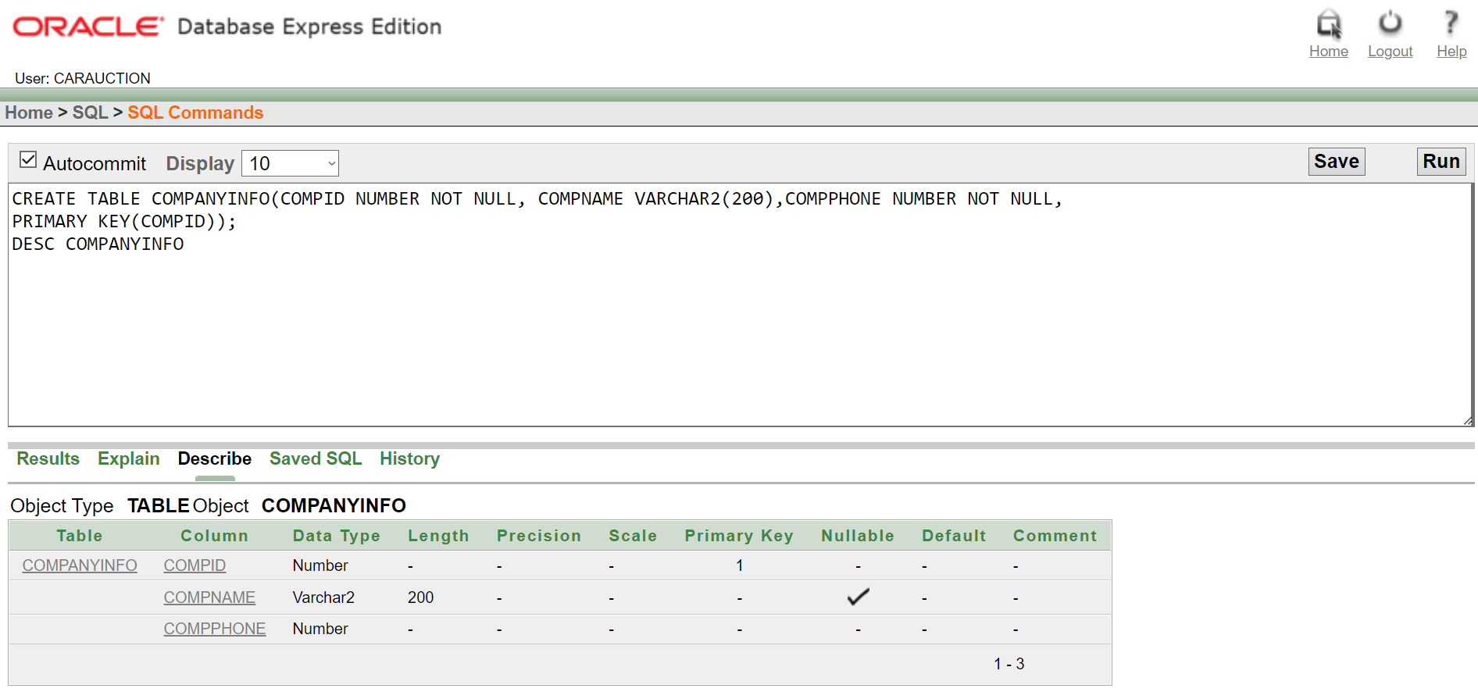

2) CREATE TABLE COMPANYADDRESS (

COMPID NUMBER, STREET VARCHAR2(200), CITY VARCHAR2 (200));

DESC COMPANYADDRESS

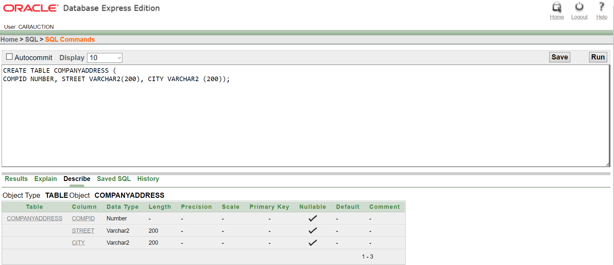

3) CREATE TABLE HAS (

ACCID NUMBER NOT NULL, ACCNAME VARCHAR2(200), ACCBALANCE NUMBER NOT NULL, ACCTRANSACTIONS NUMBER NOT NULL, COMPID NUMBER NOT NULL, PRIMARY KEY (ACCID), FOREIGN KEY (COMPID) REFERENCES COMPANYINFO(COMPID) );

DESC HAS

4) CREATE TABLE SALESMANINFO (SMID NUMBER NOT NULL, SMNAME VARCHAR2(200), PRIMARY KEY (SMID) );

DESC SALESMANINFO

5) CREATE TABLE CARINFO ( CARID NUMBER NOT NULL, CARCONDITION VARCHAR2(200), CARTYPE VARCHAR2(200),

PRIMARY KEY (CARID) );

DESC CARINFO

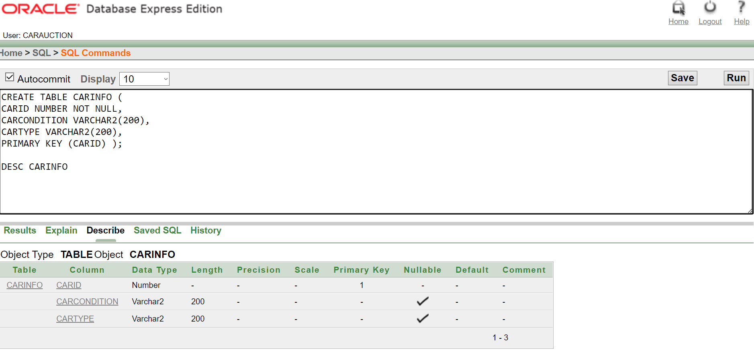

6) CREATE TABLE CARREG ( CARID NUMBER NOT NULL,

CARREG VARCHAR2(200), PRIMARY KEY (CARID));

DESC CARINFO

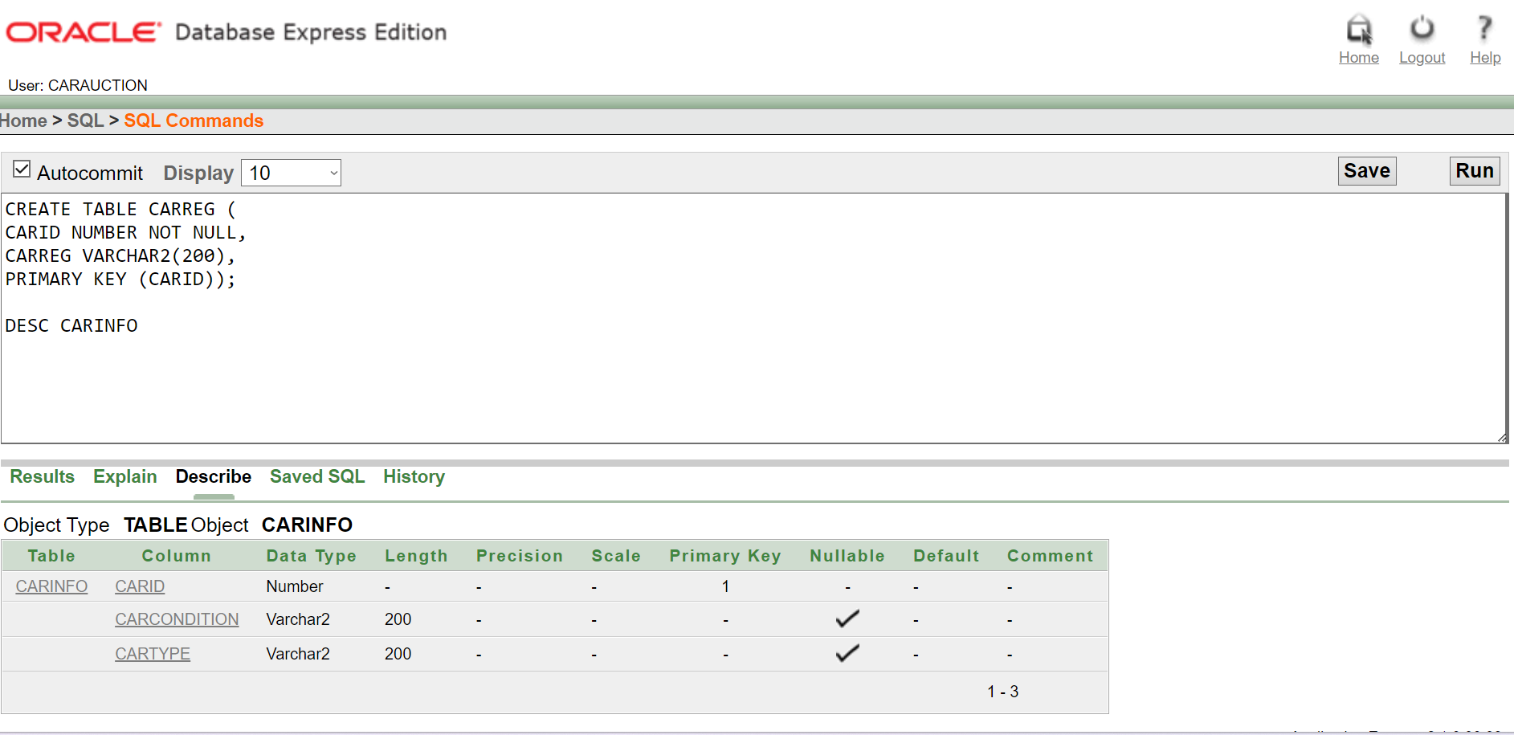

7) CREATE TABLE OWNS (COMPID NUMBER NOT NULL, GPHONE NUMBER NOT NULL, SLOTID NUMBER NOT NULL, PRIMARY KEY (SLOTID), FOREIGN KEY (COMPID) REFERENCES COMPANYINFO(COMPID));

DESC OWNS

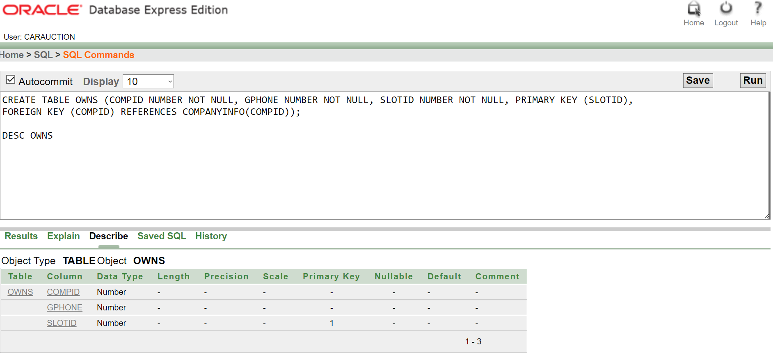

8) CREATE TABLE KEEPS ( CARID NUMBER NOT NULL, CARCONDITION VARCHAR2(200), SLOTID NUMBER NOT NULL, PRIMARY KEY (CARID), FOREIGN KEY (SLOTID) REFERENCES OWNS(SLOTID) );

DESC KEEPS

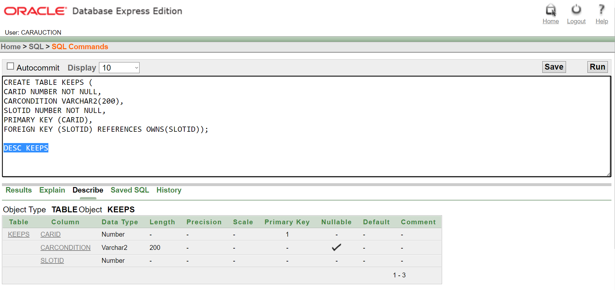

9) CREATE TABLE WORKSFOR(EMPID NUMBER NOT NULL, FNAME VARCHAR2(200),LNAME VARCHAR2(200),COMPID NUMBER NOT NULL,PRIMARY KEY (EMPID), FOREIGN KEY (COMPID) REFERENCES COMPANYINFO(COMPID));

DESC WORKSFOR

10) CREATE TABLE DEALERINFO ( DID NUMBER NOT NULL, DNAME VARCHAR2(200), PRIMARY KEY (DID));

DESC DEALERINFO

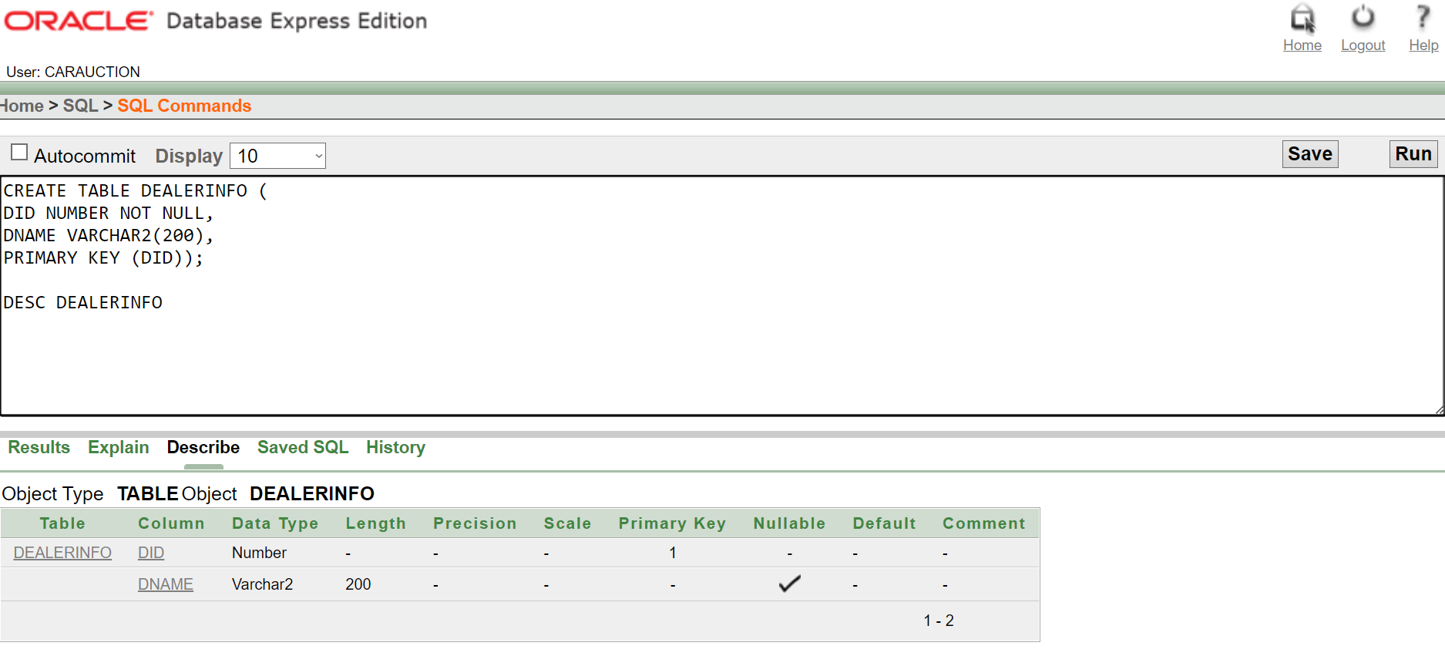

11) CREATE TABLE IMPORTSANDEXPORTS ( DID NUMBER NOT NULL, CARID NUMBER NOT NULL, PRIMARY KEY (DID), FOREIGN KEY (CARID) REFERENCES CARINFO(CARID));

DESC IMPORTSANDEXPORTS

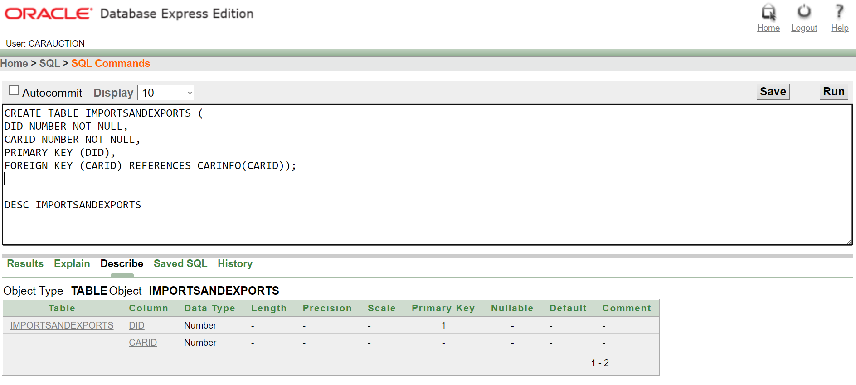

12) CREATE TABLE MANAGERINFO ( MGRID NUMBER NOT NULL, MGRNAME VARCHAR2(200), PRIMARY KEY (MGRID) );

DESC MANAGERINFO

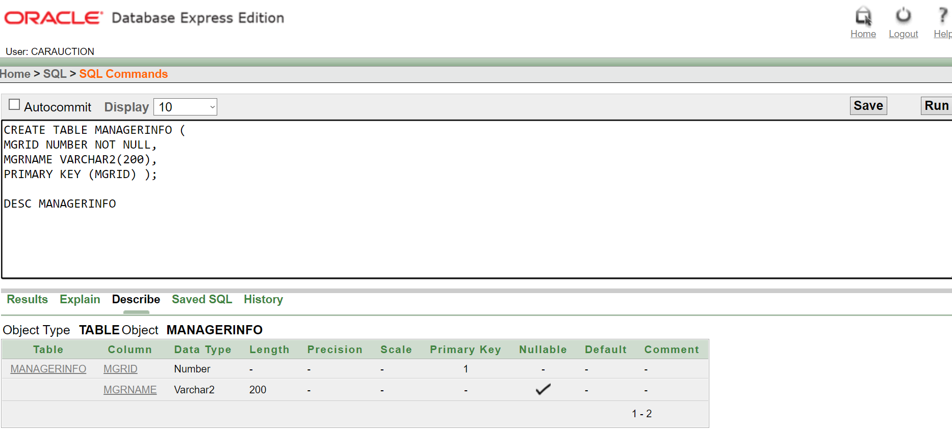

13) CREATE TABLE MANAGERCONTACT (

MGRID NUMBER NOT NULL,

MGRPHONE NUMBER NOT NULL,

PRIMARY KEY (MGRID) );

DESC MANAGERCONTACT

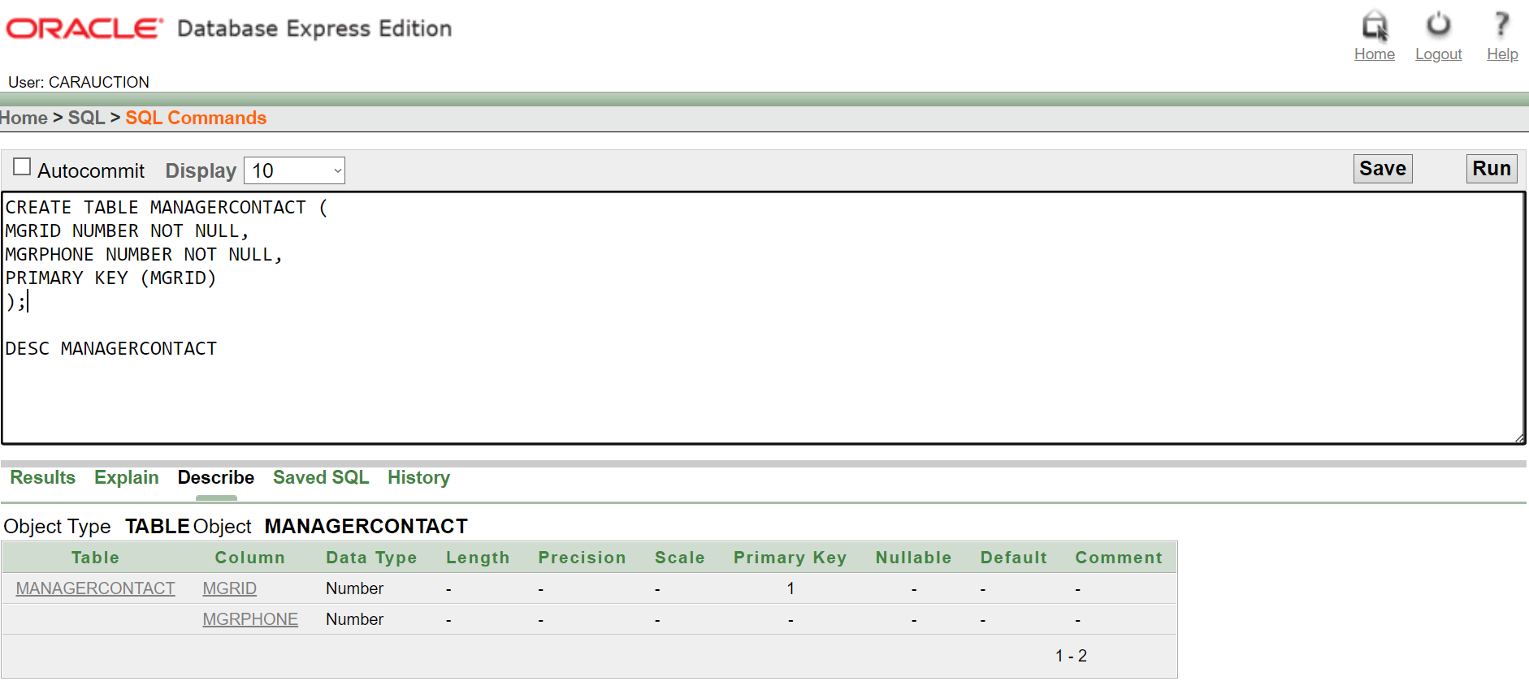

14) CREATE TABLE MANAGES ( MGRID NUMBER NOT NULL, CARID NUMBER NOT NULL, PRIMARY KEY (MGRID),

FOREIGN KEY (CARID) REFERENCES CARINFO(CARID));

DESC MANAGES

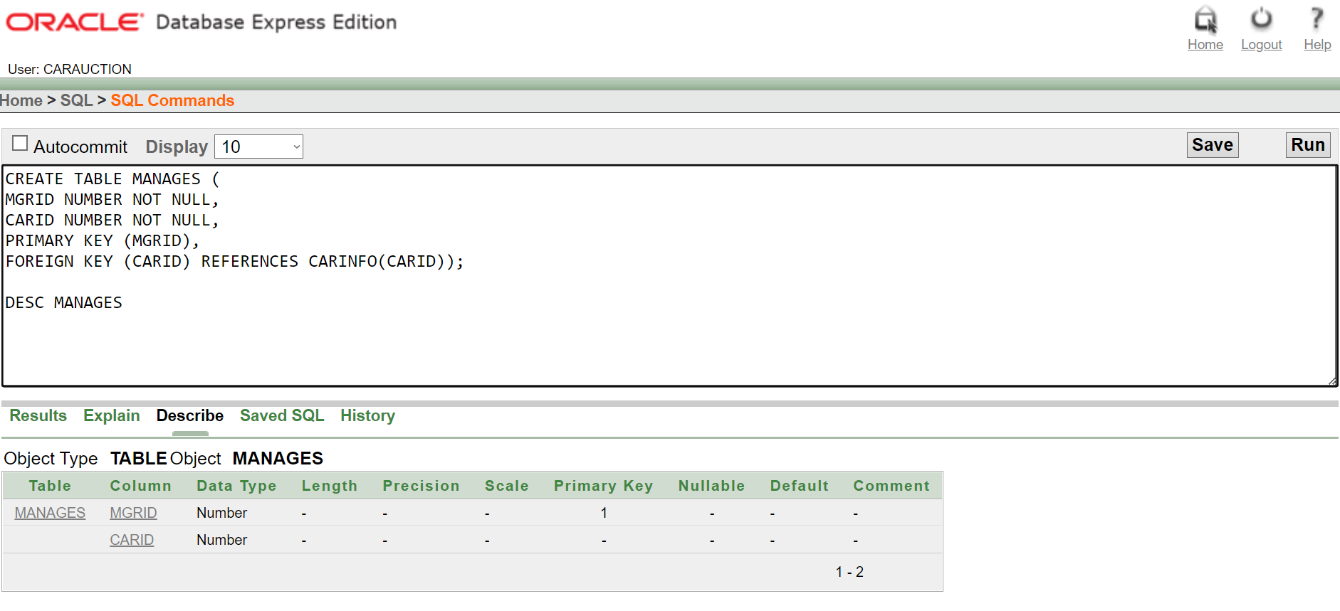

15) CREATE TABLE CUSTOMERINFO ( CID NUMBER NOT NULL, CNAME VARCHAR2(200), CEMAIL VARCHAR2(200), PRIMARY KEY (CID));

DESC CUSTOMERINFO

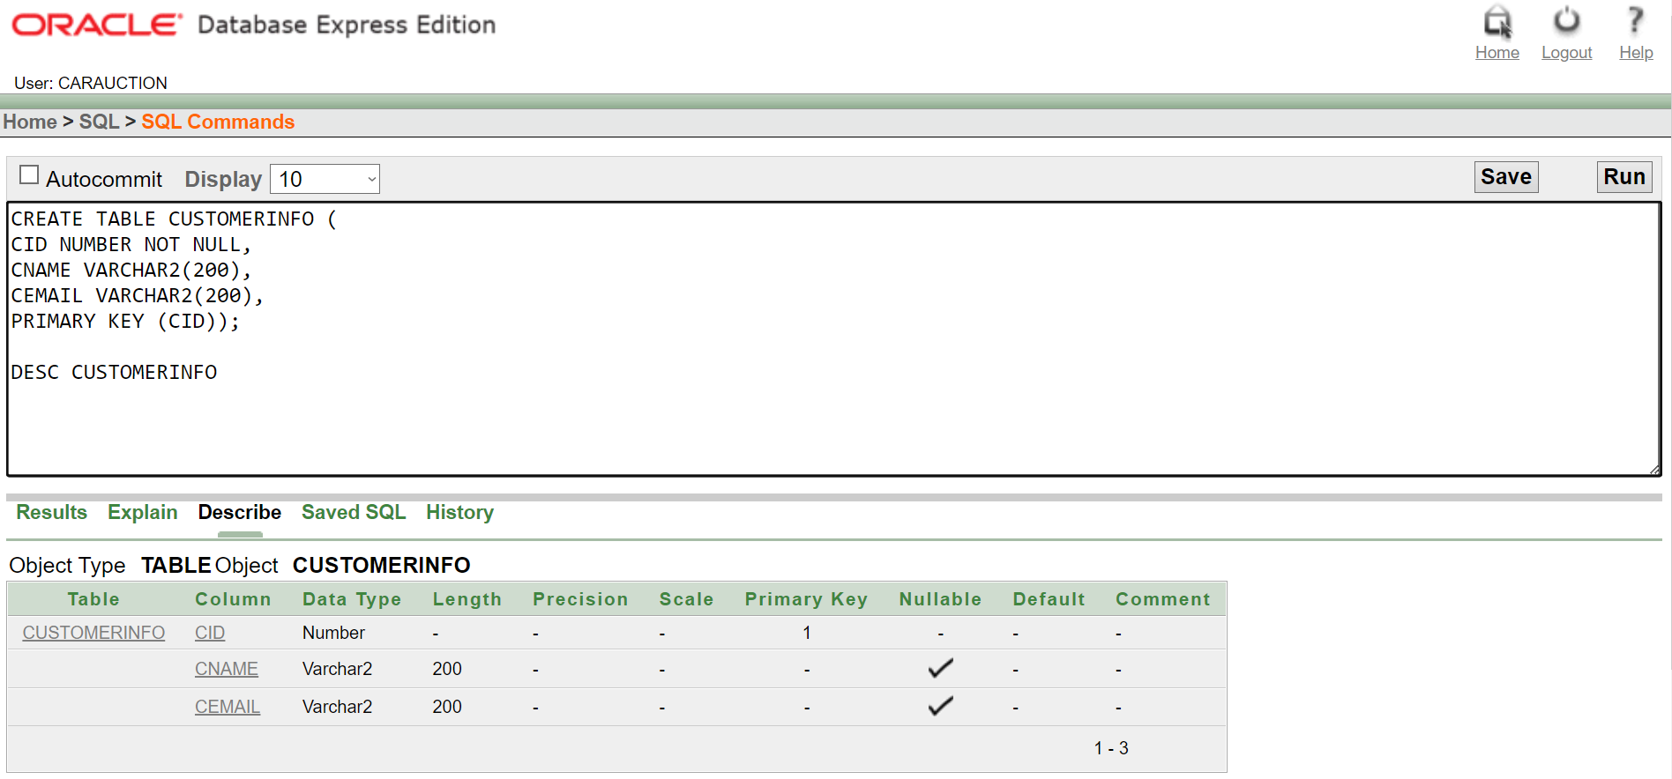

16) CREATE TABLE SOLDTO (

CID NUMBER NOT NULL,

CARID NUMBER NOT NULL,

PRIMARY KEY (CARID),

FOREIGN KEY (CID) REFERENCES CUSTOMERINFO(CID));

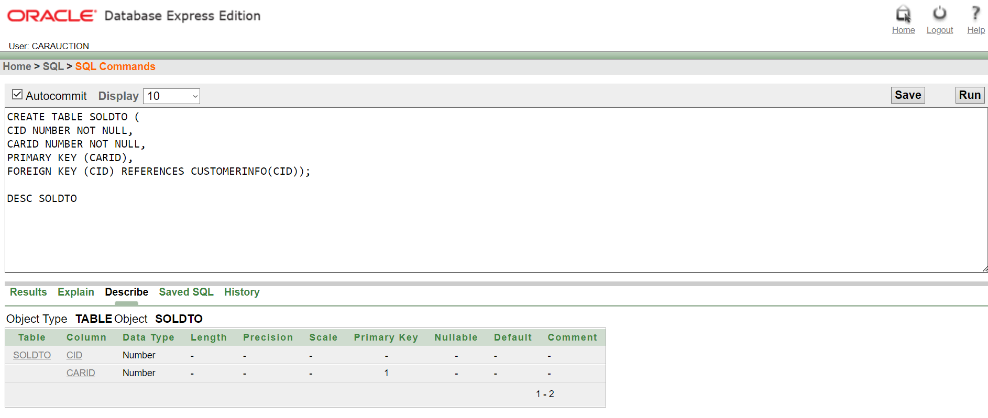

17) CREATE TABLE SECURITYINFO (

SECID NUMBER NOT NULL,

SECNAME VARCHAR2(200),

PRIMARY KEY (SECID) );

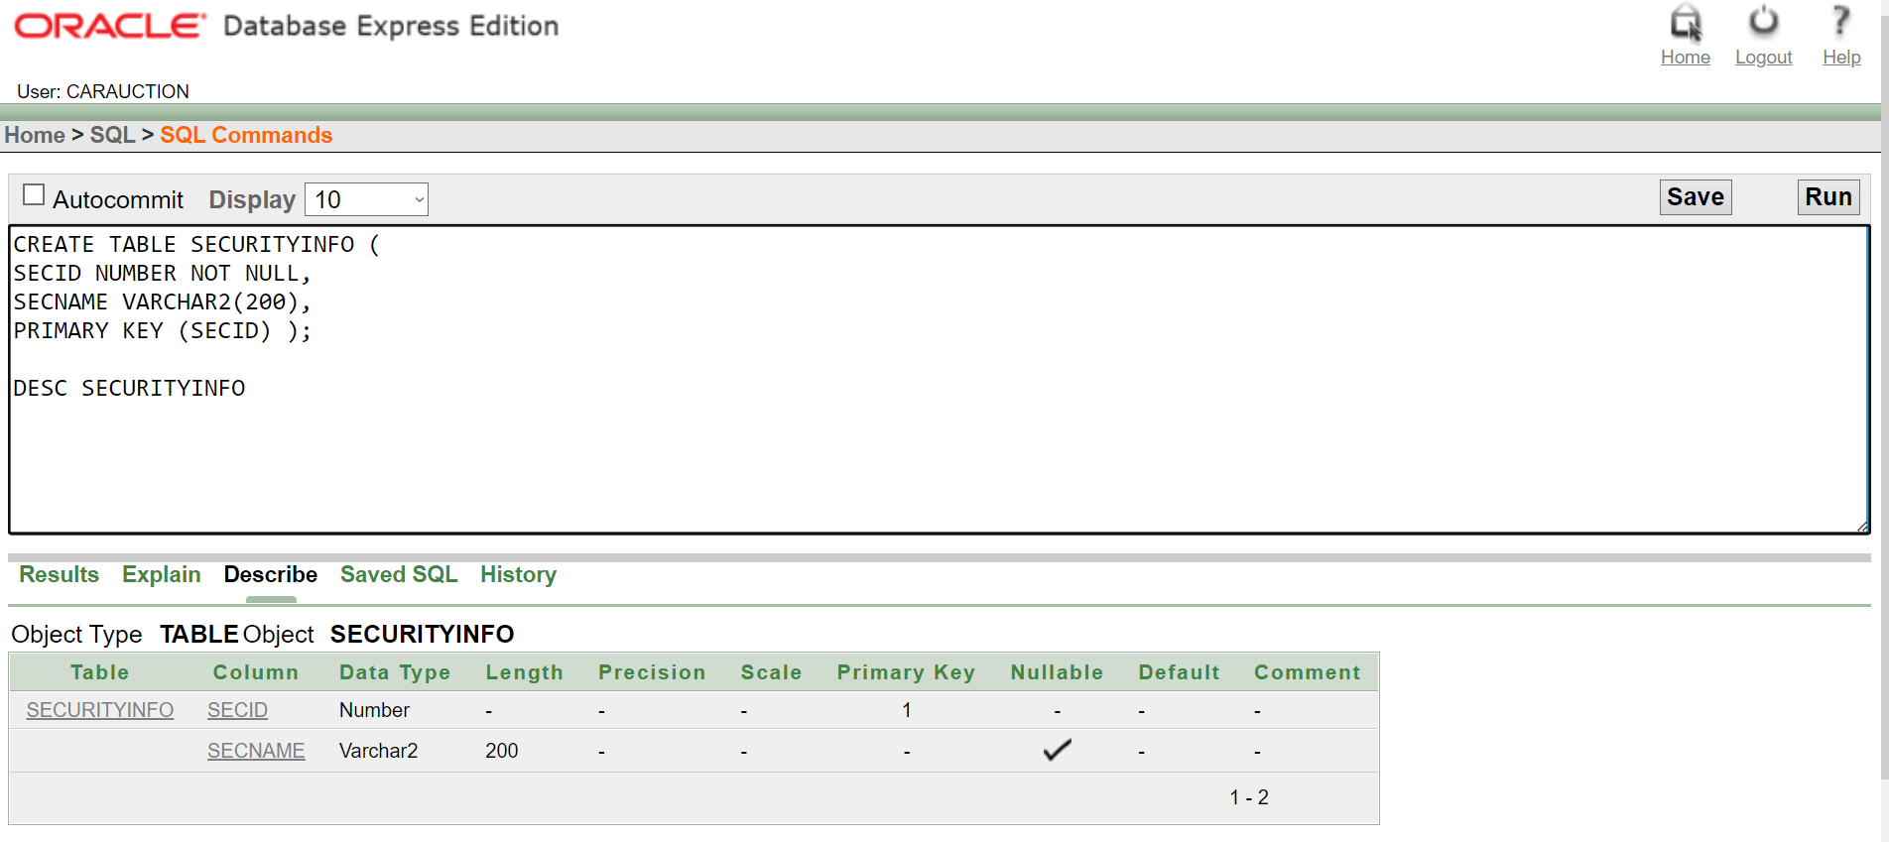

18) CREATE TABLE GUARDS (

SECID NUMBER NOT NULL, SLOTID NUMBER NOT NULL, PRIMARY KEY (SECID), FOREIGN KEY (SLOTID) REFERENCES GARAGEINFO(SLOTID) );

DESC GUARDS

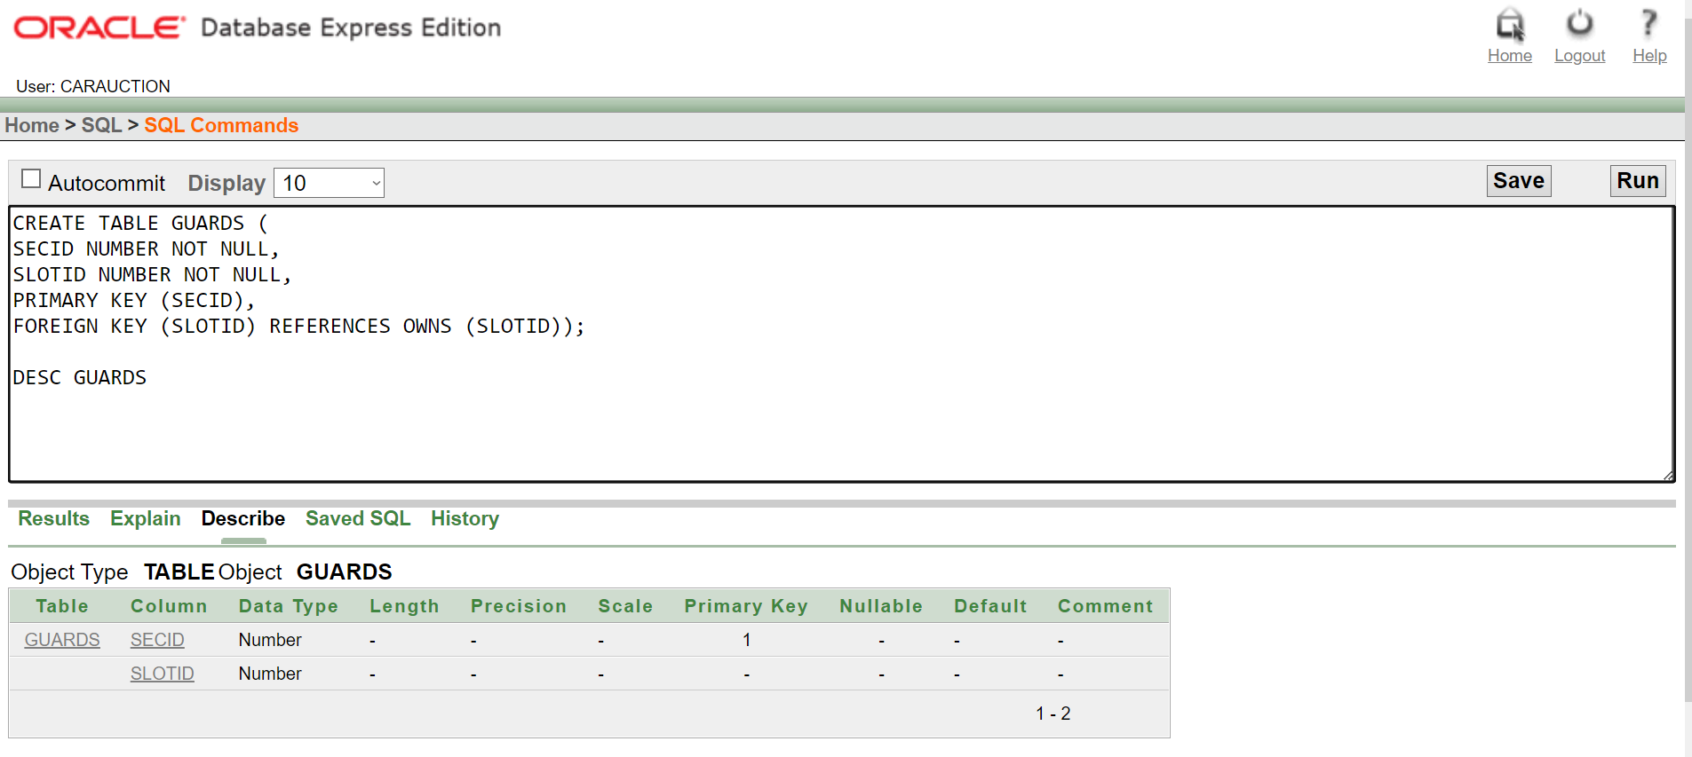

19) CREATE TABLE CLEANERINFO (

CLID NUMBER NOT NULL, CLNAME VARCHAR2(200), PRIMARY KEY (CLID));

DESC CLEANERINFO

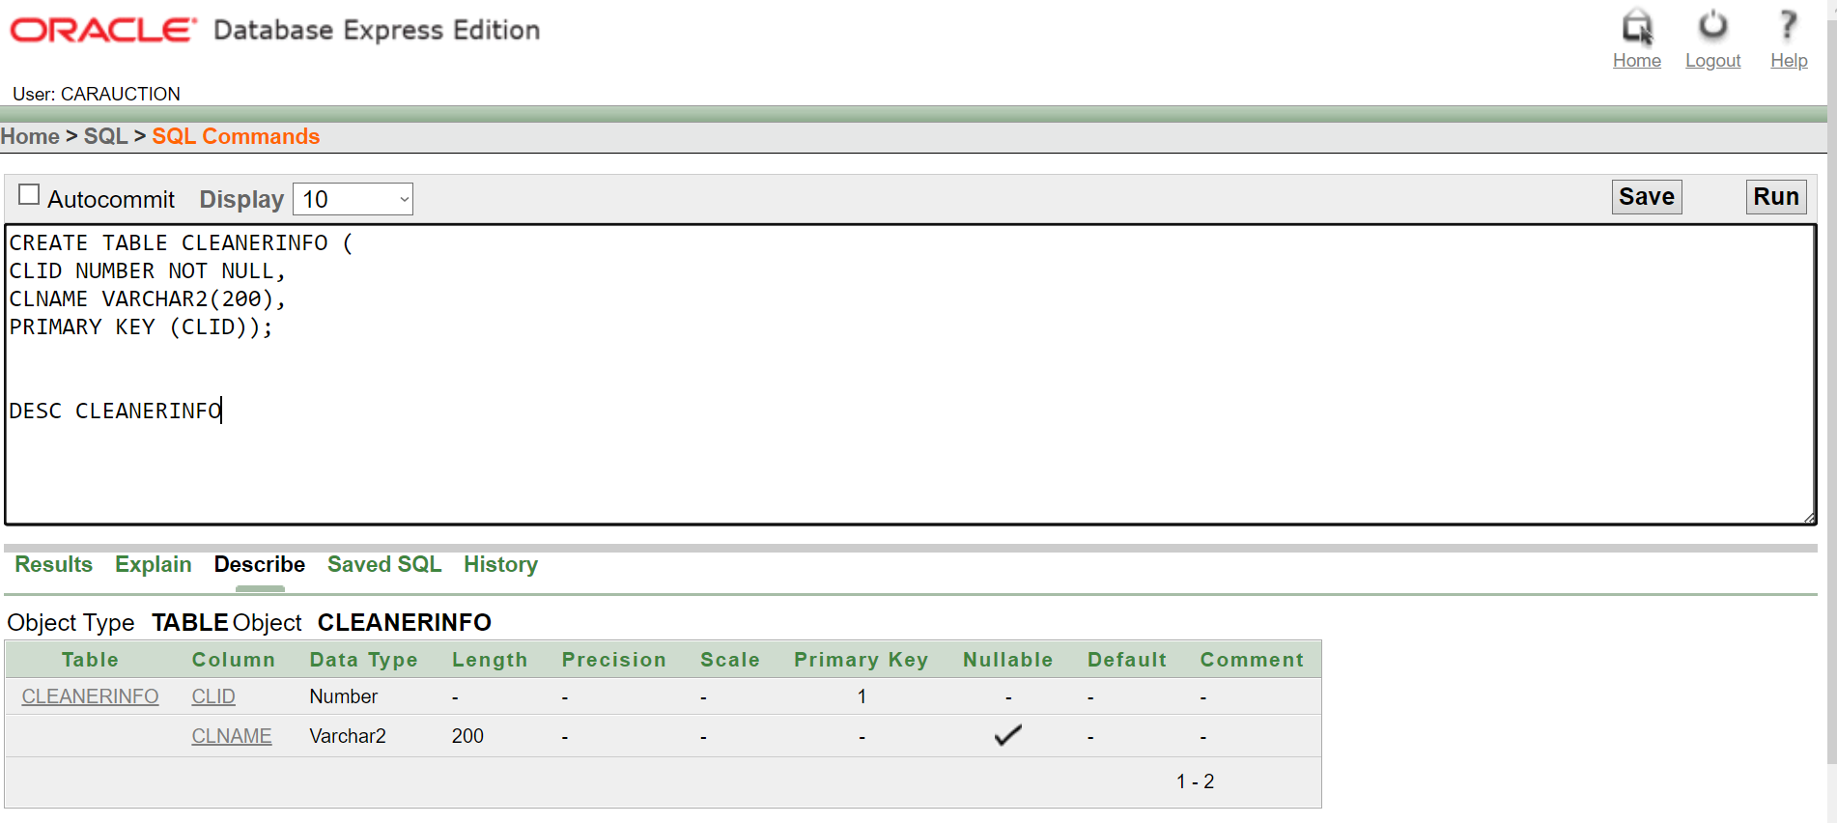

20) CREATE TABLE MAINTAINS (

MECID NUMBER NOT NULL, MECNAME VARCHAR2(200), CARID NUMBER NOT NULL, PRIMARY KEY (MECID), FOREIGN KEY (CARID) REFERENCES CARINFO(CARID) );

DESC MAINTAINS

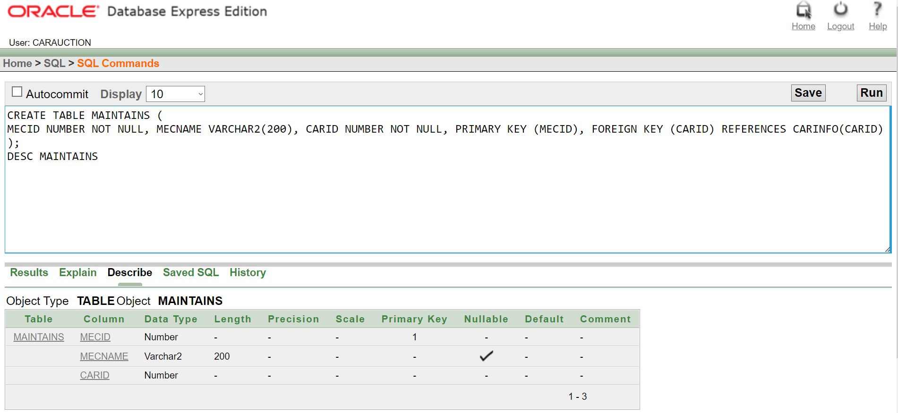

**DATA INSERTION**

INSERT INTO COMPANYINFO (COMPID, COMPNAME, COMPPHONE)

VALUES (11045666,'CAR IMPO AND EXPO',880197222292)

SELECT* FROM COMPANYINFO

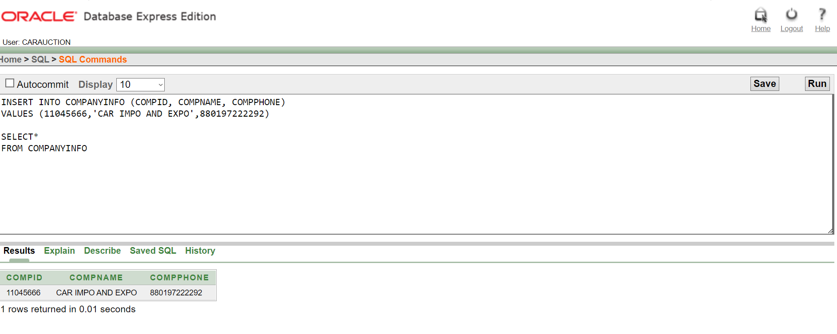



INSERT INTO COMPANYADDRESS (COMPID, STREET, CITY)

VALUES (11045666,'TEJGAO','DHAKA')

SELECT* FROM COMPANYADDRESS

INSERT INTO HAS (ACCID, ACCNAME, Accbalance, ACCTRANSACTIONS, COMPID)

VALUES(99050601,'JOHN SMITH',2000,2, 11045666);

INSERT INTO HAS (ACCID, ACCNAME, Accbalance, ACCTRANSACTIONS, COMPID)

VALUES(99050602,'WOAH GUY',1205,5, 11045666);

INSERT INTO HAS (ACCID, ACCNAME, Accbalance, ACCTRANSACTIONS, COMPID)

VALUES(99050603,'WONG LEE',10000,2, 11045666);

INSERT INTO HAS (ACCID, ACCNAME, Accbalance, ACCTRANSACTIONS, COMPID)

VALUES(66010601,'JAMES LUTHER',650,4, 11045666);

INSERT INTO HAS (ACCID, ACCNAME, Accbalance, ACCTRANSACTIONS, COMPID)

VALUES(66010602,'SUSAN DENNINGS',4000,2, 11045666);

INSERT INTO HAS (ACCID, ACCNAME, Accbalance, ACCTRANSACTIONS, COMPID)

VALUES(66010603,'SARA HOSSAIN',15000,1, 11045666);

INSERT INTO HAS (ACCID, ACCNAME, Accbalance, ACCTRANSACTIONS, COMPID)

VALUES(990332201,'Bruce wayne',20000,1, 11045666);

INSERT INTO HAS (ACCID, ACCNAME, Accbalance, ACCTRANSACTIONS, COMPID)

VALUES(990332202,'tony stark',11000,3, 11045666);

INSERT INTO HAS (ACCID, ACCNAME, Accbalance, ACCTRANSACTIONS, COMPID)

VALUES(770332201,'NAIM UDDIN',1250,1, 11045666);

INSERT INTO HAS (ACCID, ACCNAME, Accbalance, ACCTRANSACTIONS, COMPID)

VALUES(770332202,'FARUK SHIRAJ',1300,1, 11045666);

INSERT INTO HAS (ACCID, ACCNAME, Accbalance, ACCTRANSACTIONS, COMPID)

VALUES(770332203,'KAUSARUR ROHIM',800,2, 11045666);

SELECT* FROM HAS

INSERT INTO SALESMANINFO (SMID, SMNAME)

VALUES (99050601,'JOHN SMITH')

INSERT INTO SALESMANINFO (SMID, SMNAME)

VALUES (99050602,'WOAH GUY')

INSERT INTO SALESMANINFO (SMID, SMNAME)

VALUES (99050603,'WONG LEE')

SELECT* FROM SALESMANINFO

5.

INSERT INTO CARINFO (CARID, CARCONDITION, CARTYPE)

VALUES (8989005501,'MINT','SUV');

INSERT INTO CARINFO (CARID, CARCONDITION, CARTYPE)

VALUES (8989005502,'GOOD','SUV');

INSERT INTO CARINFO (CARID, CARCONDITION, CARTYPE)

VALUES (4343005501,'EXCELLENT','SEDAN');

INSERT INTO CARINFO (CARID, CARCONDITION, CARTYPE)

VALUES (4343005502,'BRAND NEW','SEDAN');

INSERT INTO CARINFO (CARID, CARCONDITION, CARTYPE)

VALUES (2022005501,'BRAND NEW','SUV');

SELECT* FROM CARINFO

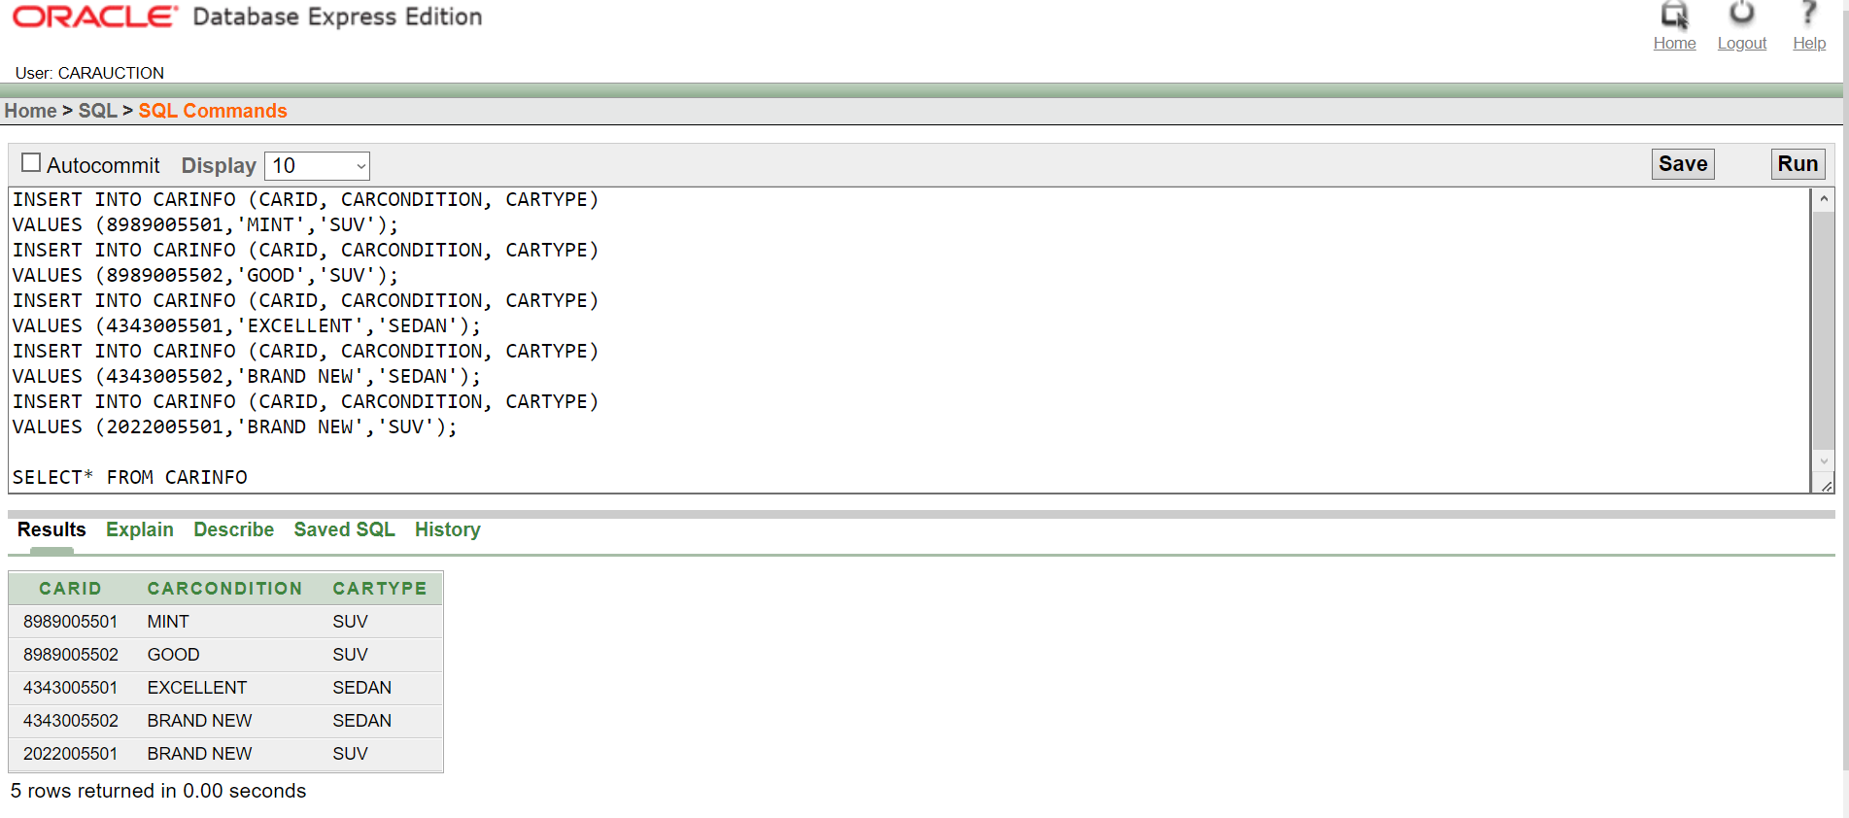

6.

INSERT INTO CARREG (CARID, CARREG)

VALUES (8989005501,'BN369147');

INSERT INTO CARREG (CARID, CARREG)

VALUES (8989005502,'BN258456');

INSERT INTO CARREG (CARID, CARREG)

VALUES (4343005501,'TRO9137SE');

INSERT INTO CARREG (CARID, CARREG)

VALUES (4343005502,'GTR005121');

INSERT INTO CARREG (CARID, CARREG)

VALUES (2022005501,'VIP00001');

SELECT* FROM CARREG

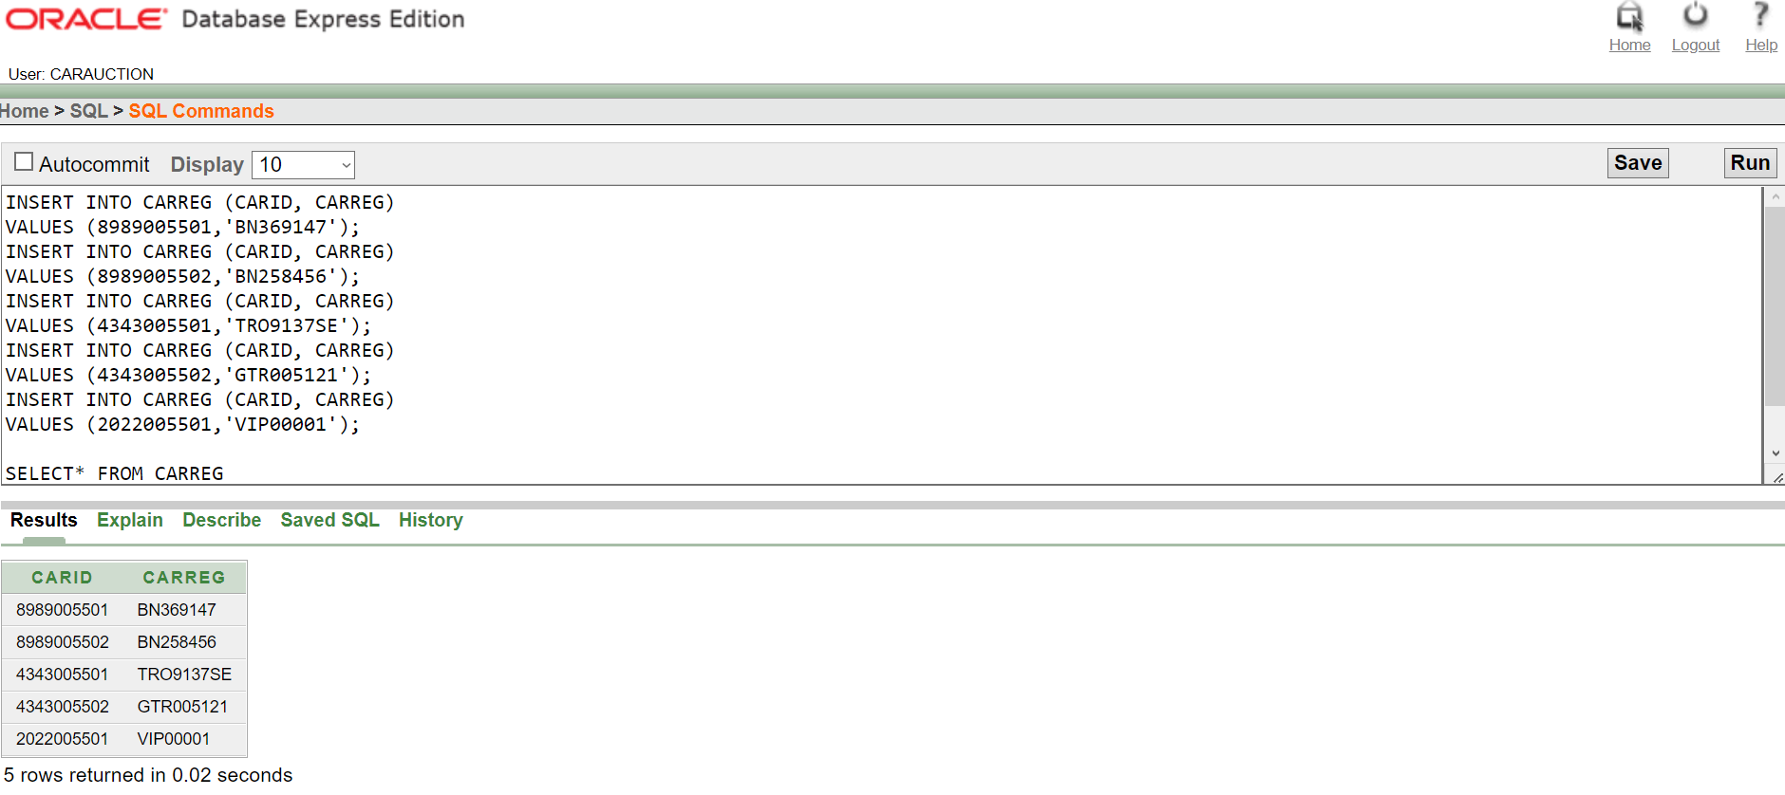

7.

INSERT INTO OWNS(SLOTID,GPHONE,COMPID)

VALUES(01,8801517464238,11045666);

INSERT INTO OWNS(SLOTID,GPHONE,COMPID)

VALUES(02,8801517464239,11045666);

INSERT INTO OWNS(SLOTID,GPHONE,COMPID)

VALUES(03,8801517464240,11045666);

INSERT INTO OWNS(SLOTID,GPHONE,COMPID)

VALUES(04,8801517464241,11045666);

SELECT* FROM OWNS

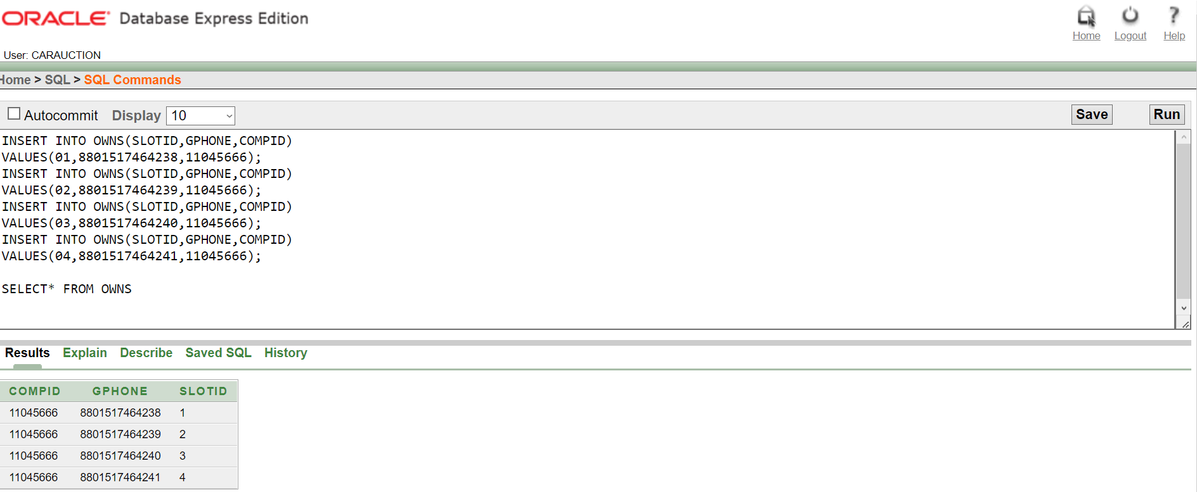

8.

INSERT INTO KEEPS(CARID,CARCONDITION,SLOTID)

VALUES(8989005501,'MINT',01);

INSERT INTO KEEPS (CARID,CARCONDITION,SLOTID)

VALUES (8989005502,'GOOD',01);

INSERT INTO KEEPS (CARID,CARCONDITION,SLOTID)

VALUES (4343005501,'EXCELLENT',01);

INSERT INTO KEEPS (CARID,CARCONDITION,SLOTID)

VALUES (4343005502,'BRAND NEW',02);

INSERT INTO KEEPS (CARID,CARCONDITION,SLOTID)

VALUES (2022005501,'BRAND NEW',02);

SELECT* FROM KEEPS

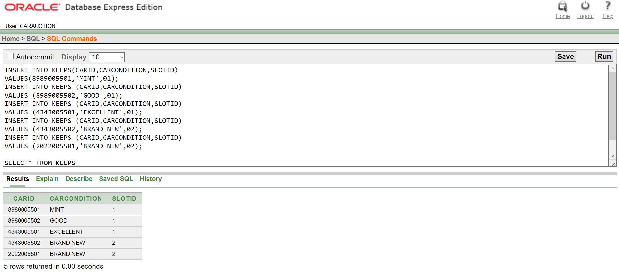

9.

INSERT INTO WORKSFOR (EMPID,FNAME,LName,COMPID)

VALUES(99050601,'JOHN', 'SMITH', 11045666);

INSERT INTO WORKSFOR (EMPID,FNAME,LNAME,COMPID)

VALUES(99050602,'WOAH','GUY', 11045666);

INSERT INTO WORKSFOR (EMPID,FNAME,LNAME,COMPID)

VALUES(99050603,'WONG','LEE', 11045666);

INSERT INTO WORKSFOR (EMPID,FNAME,LNAME,COMPID)

VALUES(66010601,'JAMES','LUTHER', 11045666);

INSERT INTO WORKSFOR (EMPID,FNAME,LNAME,COMPID)

VALUES(66010602,'SUSAN','DENNINGS', 11045666);

INSERT INTO WORKSFOR (EMPID,FNAME,LNAME,COMPID)

VALUES(66010603,'SARA','HOSSAIN', 11045666);

INSERT INTO WORKSFOR (EMPID,FNAME,LNAME,COMPID)

VALUES(990332201,'Bruce','wayne', 11045666);

INSERT INTO WORKSFOR (EMPID,FNAME,LNAME,COMPID)

VALUES(990332202,'tony','stark', 11045666);

INSERT INTO WORKSFOR (EMPID,FNAME,LNAME,COMPID)

VALUES(770332201,'NAIM','UDDIN', 11045666);

INSERT INTO WORKSFOR (EMPID,FNAME,LNAME,COMPID)

VALUES(770332202,'FARU','SHIRAJ', 11045666);

INSERT INTO WORKSFOR (EMPID,FNAME,LNAME,COMPID)

VALUES(770332203,'KAUSARUR','ROHIM', 11045666);

SELECT* FROM WORKSFOR

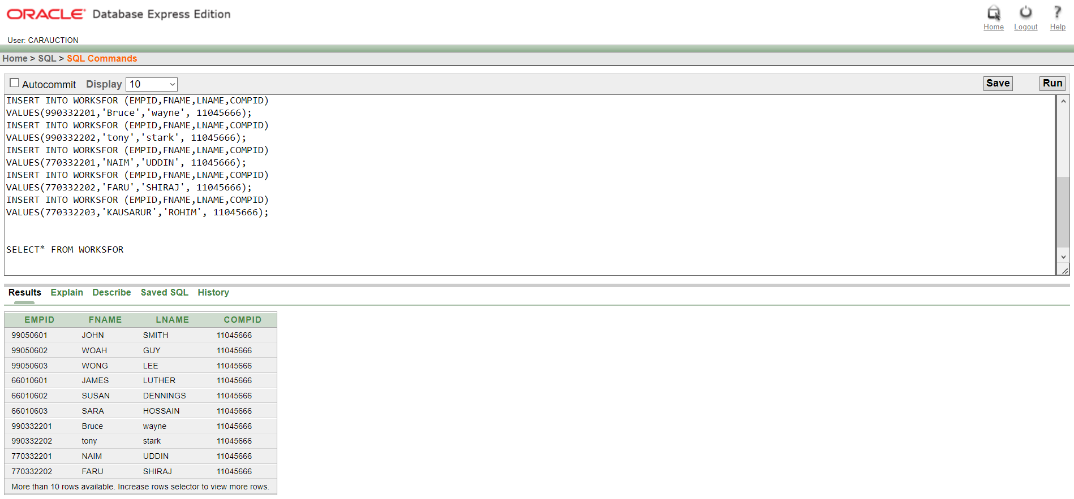

10.

INSERT INTO DEALERINFO (DID,DNAME)

VALUES(66010601,'JAMES LUTHER');

INSERT INTO DEALERINFO (DID,DNAME)

VALUES(66010602,'SUSAN DENNINGS');

INSERT INTO DEALERINFO (DID,DNAME)

VALUES(66010603,'SARA HOSSAIN');

INSERT INTO DEALERINFO (DID,DNAME)

VALUES(66010604,'ALLEN KAIS');

SELECT* FROM DEALERINFO

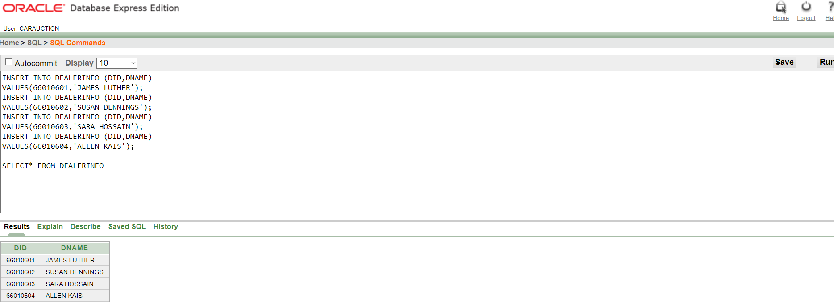

11.

INSERT INTO IMPORTSANDEXPORTS (DID, CARID)

VALUES(66010602, 8989005501);

INSERT INTO IMPORTSANDEXPORTS (DID, CARID)

VALUES(66010603, 4343005502);

INSERT INTO IMPORTSANDEXPORTS (DID, CARID)

VALUES(66010604, 2022005501);

SELECT* FROM DEALERINFO

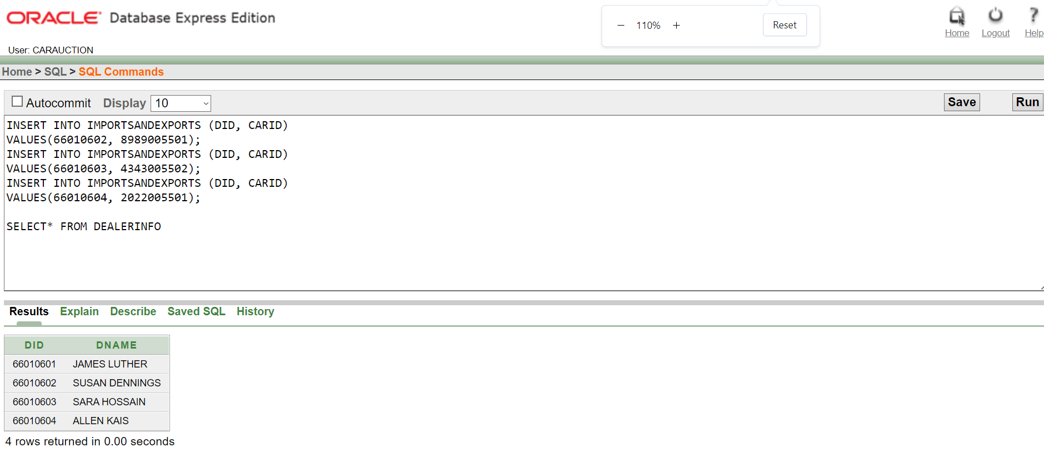

12.

INSERT INTO MANAGERINFO (MGRID,MGRNAME)

VALUES (990332201,'Bruce wayne');

INSERT INTO MANAGERINFO (MGRID,MGRNAME)

VALUES (990332202,'tony stark');

INSERT INTO MANAGERINFO (MGRID,MGRNAME)

VALUES (990332203,'Jim Len');

SELECT* FROM MANAGERINFO

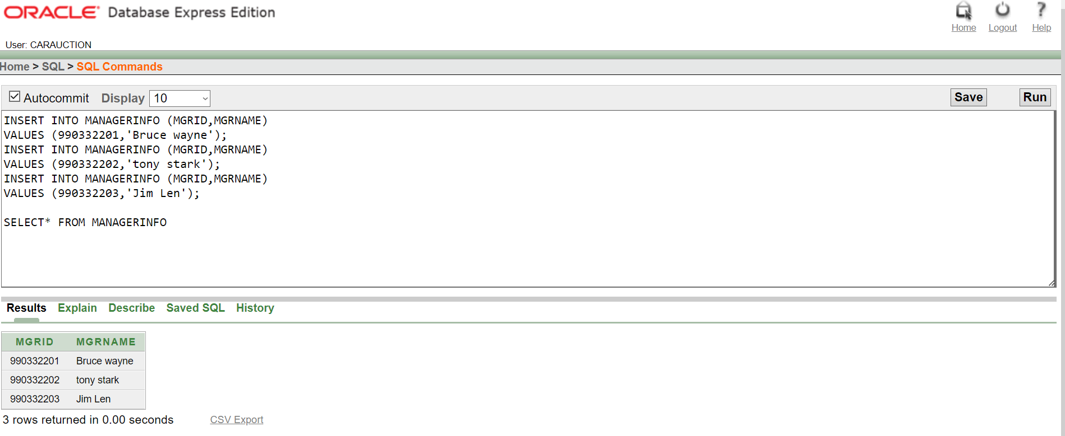

13.

INSERT INTO MANAGERCONTACT (MGRID,MGRPHONE)

VALUES (990332201,88019178987611);

INSERT INTO MANAGERCONTACT (MGRID,MGRPHONE)

VALUES (990332202, 88019178987612);

INSERT INTO MANAGERCONTACT (MGRID,MGRPHONE)

VALUES (990332203, 88019178987612);

SELECT* FROM MANAGERINFO

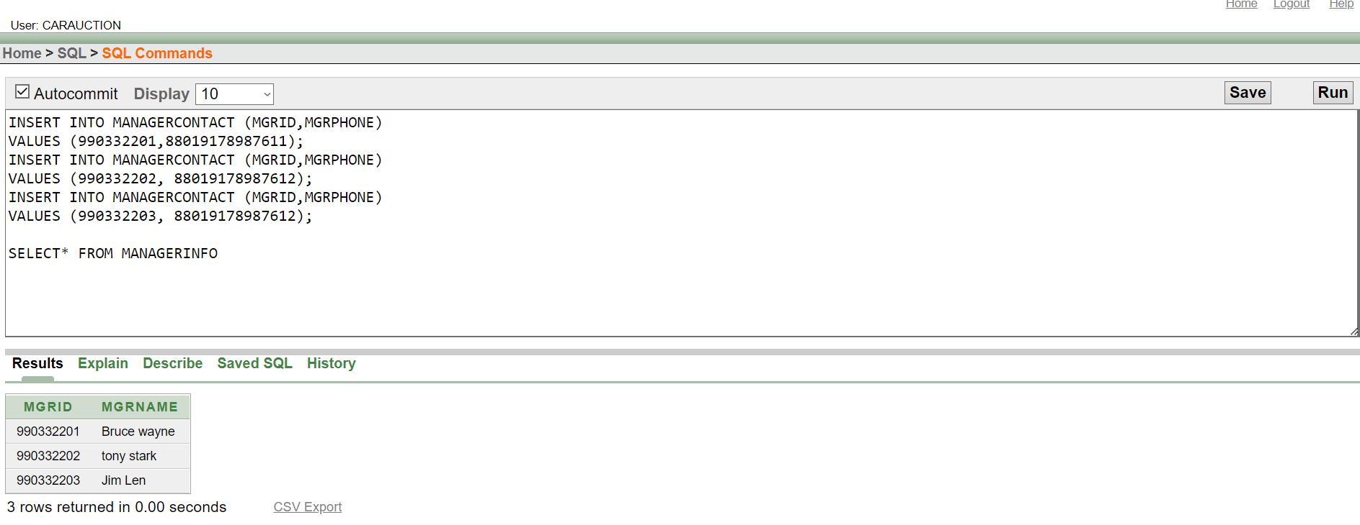

14. INSERT INTO MANAGES (MGRID,CARID)

VALUES (990332201, 8989005501);

INSERT INTO MANAGES (MGRID,CARID)

VALUES (990332201, 8989005502);

ERROR

15.

INSERT INTO CUSTOMERINFO (CID,CEMAIL,CNAME)

VALUES(7704,'SAKIB.H1212@GMAIL.COM','SAKIBAL HASAN')

INSERT INTO CUSTOMERINFO (CID,CEMAIL,CNAME)

VALUES(7705,'OBAIDUL.K@GMAIL.COM','OBAIDUL KAKA');

INSERT INTO CUSTOMERINFO (CID,CEMAIL,CNAME)

VALUES(7703,'SHIROOO@GMAIL.COM','PRINCE SHIRO');

SELECT* FROM CUSTOMERINFO

